If you can dream it you can do it

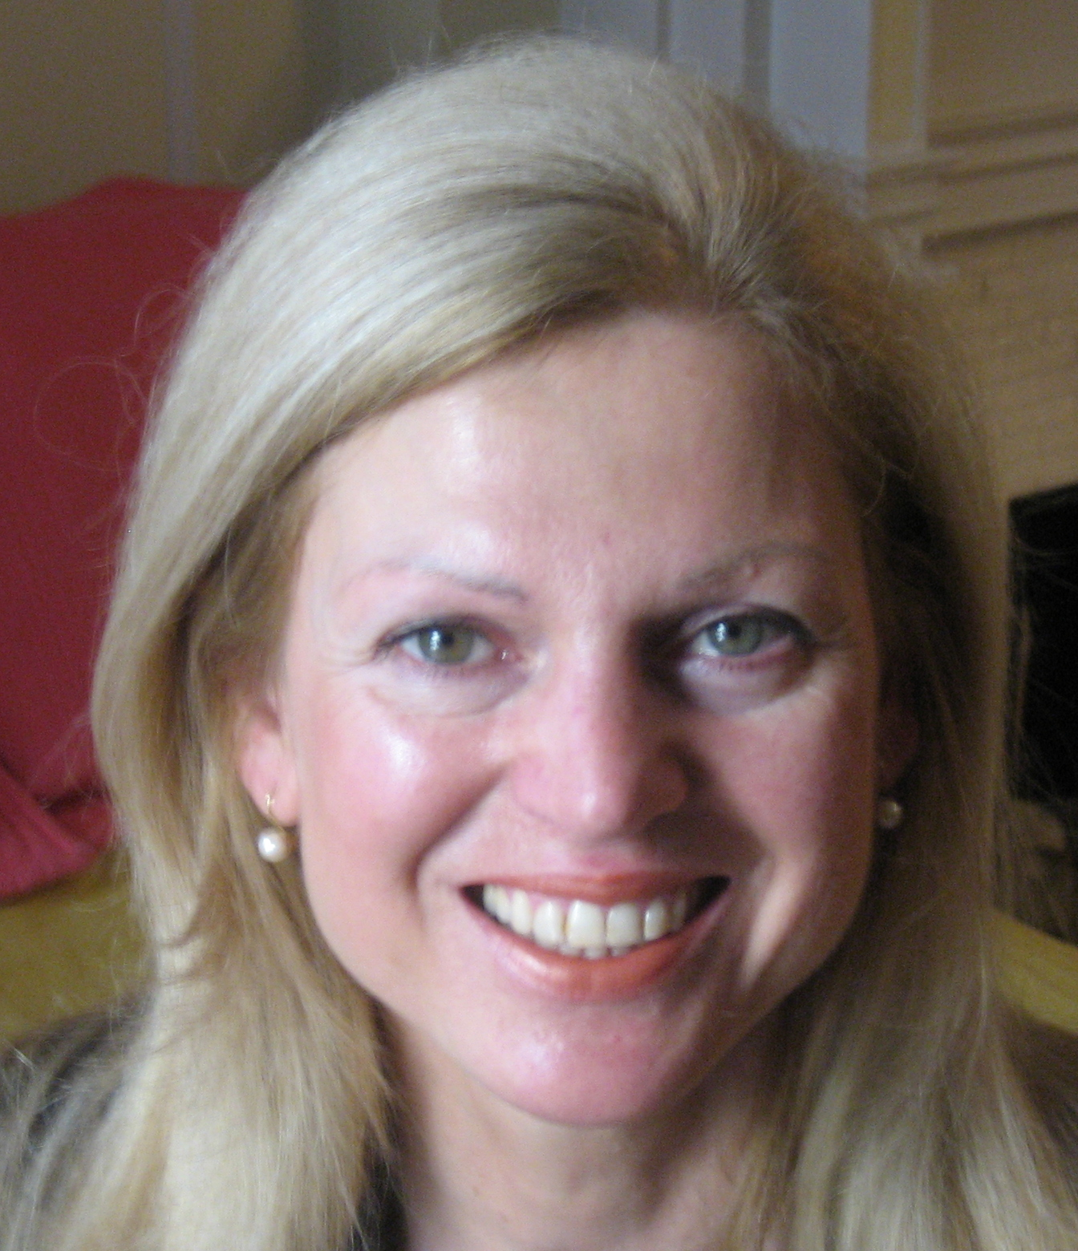
Claudia Bayr
is an International Certified DreamCoach® in NYC.
claudia@dreamsintoactions.com
www.dreamsintoactions.com

Failure can lead to Success

Providing you take Winston Churchill’s words to heart: “Success is a series of failures without any loss of enthusiasm,” explains Certified Dream Coach® Claudia Bayr.
Our failures are an important learning tool in our lives. If you look at your greatest failure in life, you could well discover that it has also been your greatest teacher. Winston Churchill’s definition of success makes you realize that there are hidden gifts in our failures, mistakes or setbacks. There is often an unquestioned belief that failure is ‘bad’.
We are born into an overambitious society where parents, caregivers or teachers were inclined to be judged by our performance. They had to “look good”. They rarely, if ever, allowed us to make mistakes and feel OK about it. Often we experienced criticism, embarrassment and were made to feel guilty. Our early childhood response to that was a little voice that said: “I am bad,” “I am not loved,” “I am not accepted,” “I am not smart enough,” etc.
Any of these mental-emotional responses will stop us from taking any risks, will make us fearful in interactions with others, and leave us without power as an individual. We internalize the criticism of our caregivers, setting up failure-mechanisms. Accepting these judgments has become the cause of our own failures.

Here are five tips on looking at your failures or setbacks from a new perspective:

- Understand that you are not your failure, and try to keep up your enthusiasm.
- Own your failure – look at it as an opportunity to learn and to grow.
- Know that life is a process and not a destination. Our setbacks are part of our path and destiny.
- Take your failure as a measure of your commitment to your vision. For example, Martin Luther King had “a dream” – that and only that pulled him through all his failures!
- Get comfortable with smaller steps. As they say: “If you fall off a horse, try to get on a pony.”

My dream was always to speak in public, but at the same time that was also my greatest fear. As a sales representative for a major international design company, I had terribly embarrassed myself in presentations to the Board of Directors. Authority scared me, and my little voice told me, “You are not good enough”.
In retrospect, I realize that all my anxiety and stress was self-inflicted. Years later when I met one of those directors, he told me that I used to be a bit shy. What has really helped me was to look at this failure from a new perspective. Realizing we are usually our own worst taskmasters, I had to forgive myself. I took external action by enrolling in Toastmasters and reading books about public speaking.
What I have learnt from my failures is to be vulnerable, allowing other people to be there supporting me. This has led me to a deeper connection, acceptance and love for others, as well as for myself. True connection and love dissolve all fear!
As a Certified Dream Coach®, I assist you in opening up new perspectives in your life, overcoming your fears, increasing your confidence, and leading the life you want to live. If you can dream it, you can do it! www.dreamsintoactions.com
For a complimentary phone coaching session please email claudia@dreamsintoactions.com or call 212-501-3827.

